TECHNICAL PROJECT REPORT

Comparative Study of Traditional Machine Learning and Transformer Models for Spam classification

Submitted by : Tanuradha Sharma

Introduction
People receive many unwanted messages, including advertisements, fake offer, and messages with suspicious links. These unwanted messages are commonly called spam. A spam classification system tries to identify whether a message is spam or ham, In this project means a normal message and spam means an unwanted message.
The aim is to compare traditional machine learning with a transformer- based approach. The traditional models are Logistic Regression and Naïve Bayes. The transformer model is Distil BERT, fine-tuned with PyTorch. The models are evaluated using the same main measures so their results can be compared.

Objectives of the Project
The main objectives of this project are :
- To understand and clean the given dataset
- To convert text messages into numerical features using TF- IDF
- To build a spam classification system using Logistic Regression and Naïve Bayes.
- To train a DistilBERT model using PyTorch.
- To evaluate the model using accuracy, Precision, recall, and F1- score.
- To compare the performance and training time of all models.
- To display the results using graphs and confusion matrices
Dataset Description
For this project, I used the provided email.csv dataset. It contains two main columns.
- Category: It tells us whether the message is spam or ham
- Messages: It contains the actual text of the message.
Before training the models, I checked the dataset for invalid labels empty messages, and duplicate records. I removed invalid records and duplicate rows to improve data quality.
After cleaning, the dataset contained 5,157 unique messages.
Category | Number of messages
Ham | 4,516
Spam | 641
Total | 5,157

The dataset contains more ham messages than spam messages. This difference is called class imbalance. Therefore, I used multiple evaluation metrices to understand how well the models detect spam.
The dataset mainly contains messages, so the result may not represent every type of full-length email.

Methodology
In Project is divided into two parts.
- Traditional Machine Learning
I used traditional machine learning techniques to classify messages.
TF-IDF:TF-IDF converts text into numerical values that machine learning models can process. It gives importance to words based on their occurrence in the messages.
Logistic Regression: This model learns patterns from the training data and uses them to predict whether a message is spam or ham .
Naïve Bayes : This model uses probability to classify messages based on the words they contain.
I divided the dataset into 80% training data and 20% testing data. The training data was used to teach the models, while the testing data was used to check their performance on unseen messages.

- Transformer-Based model: DistilBERT
In the second part, I used DistilBERT, a transformer-based deep learning model. It learns contextual relationships between words and represents text in a way that can help with classification.
I used a tokenizer to convert messages into numerical tokens. Then, I fine-tuned DistilBERT using PyTorch and implemented my own training loop, as required by the assignment.
The initial training settings were a learning rate of 0.00002, a batch size of 16, and three epochs. I used a validation dataset to monitor training and a separate test dataset for final evaluation.
Tools and Technologies Used
Tools or technology | Writing the project code
Python | Loading and cleaning the dataset
Pandas | Building traditional models and evaluating predictions
Scikit-learn | Converting text into numerical features
TF-IDF | Training the DistilBERT model
PyTorch | Training the DistilBERT
Hugging Face Transformers | Loading DistilBERT
Matplotlib | Creating graphs
Seaborn | Creating visualizations and confusion matrices
Evalution Metrics
I used the following evaluation metrices to compare the models.
Accuracy: It tells us how many predictions are correct out of all predictions.
Precision: It tells us how many messages predicted as spam are actually spam.
Recall: It tells us how many actual spam messages the model successfully identifies.
F1-score: It combines precision and recall into a single score.
Confusion Matrix: It shows the number of correct and incorrect predictions for spam and ham.
These metrices help us understand the performance of each model more clearly.
Experimental Results and Discussion
The traditional machine learning models were evaluated using the same held-out test dataset.
The measured results were:
Model | Accuracy | Precision | Recall | F1-score
Logistic Regression | 97.48% | 90.48% | 89.06% | 89.76%
Naïve Bayes | 96.22% | 100.00% | 69.53% | 82.03%
DistilBERT | 98.45% | 95.16% | 92.19% | 93.65%
Logistic Regression achieved higher accuracy, recall, and F1-score than Naive Bayes in this experiment. It identified more spam messages, although it incorrectly classified some normal messages as spam.
Naive Bayes achieved higher precision, meaning that all messages it predicted as spam were spam in this test set. However, it missed more actual spam messages than Logistic Regression.
DistilBERT must be trained and evaluated before its results can be compared with the traditional models.

Visualizations
The following graphs are used to understand and compare the models:
- Metric comparison graph: Compares accuracy, precision, recall, and F1-score.
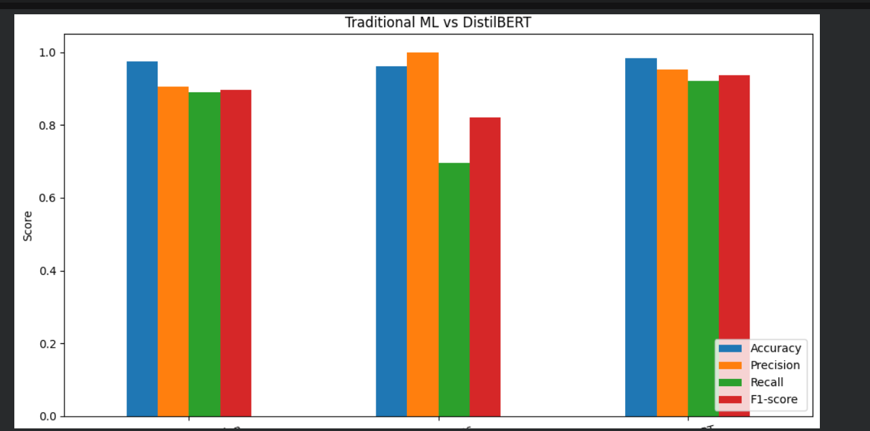
- Confusion matrices: Show correct and incorrect predictions for each class.
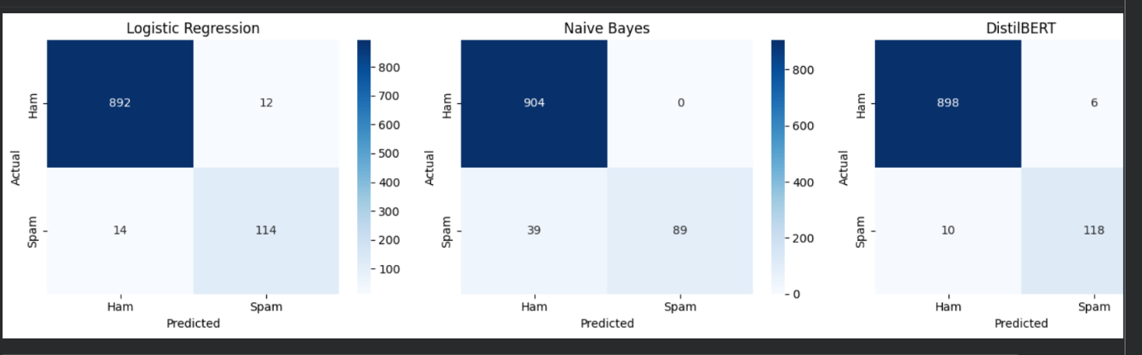
- Training and validation loss graph: Shows how DistilBERT learns during training.
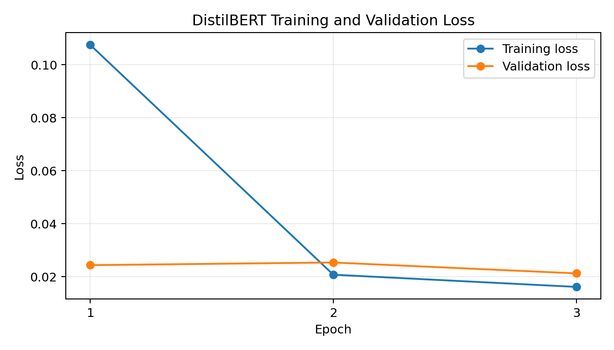

- Training-time comparison graph: Compares the time taken to train each mode
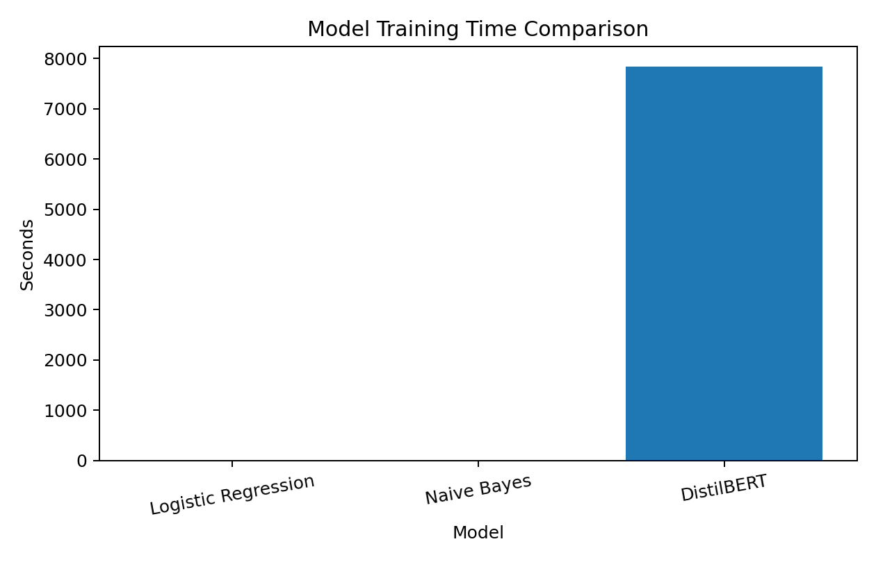
These visualizations make the results easier to understand.
Computational Cost
Traditional machine learning models are generally simpler and faster to train than transformer-based models.
In my traditional-model experiment, Logistic Regression took approximately 0.518 seconds to fit, while Naive Bayes took approximately 0.023 seconds. These measurements cover model fitting after TF-IDF features were prepared, not the entire project runtime.
DistilBERT requires more memory and computational resources. Its actual training time must be measured after running the transformer training code.

Limitations
This project has some limitations.
- The dataset contains more ham messages than spam messages.
- The dataset is limited in size and mainly contains short messages.
- The results may change with different data splits and model settings.
- DistilBERT requires more computational resources and training time.
- All models may make incorrect predictions on unfamiliar messages.
In the future, the project can be improved by using a larger and more diverse dataset, testing additional messages, and adjusting model parameters.

Conclusion
In this project, I studied and compared traditional machine learning and transformer-based approaches for spam classification.
I used TF-IDF with Logistic Regression and Naive Bayes for the traditional approach. I also prepared a DistilBERT approach using PyTorch, as required by the assignment.
The measured results showed that Logistic Regression performed better than Naive Bayes in recall and F1-score on the test dataset, while Naive Bayes had higher precision and lower model-fitting time.
The final comparison with DistilBERT can be completed after training and evaluating it on the same test dataset.
Through this project, I learned how to clean data, process text, train machine learning models, evaluate results, and visualize model performance.
Future Scope
This project can be improved in several ways:
- Use a larger dataset containing different types of emails.
- Improve the models by tuning their parameters.
- Test the models on more real-world messages.
- Reduce the computational cost of transformer training.
- Develop a simple web application where users can enter a message and check whether it is spam or ham.

